[**Are Unicode and Ascii characters the same?**](http://stackoverflow.com/questions/10361579/are-unicode-and-ascii-characters-the-same)

<http://stackoverflow.com/questions/10361579/are-unicode-and-ascii-characters-the-same>

Unicode is a way to assign unique numbers (called code points) to almost every character that is in active use today. This includes characters from nearly all languages plus many other characters such as mathematical symbols. There are many ways to encode Unicode strings as bytes, such as [UTF-8](http://en.wikipedia.org/wiki/UTF-8) and[UTF-16](http://en.wikipedia.org/wiki/UTF-16/UCS-2).

ASCII assigns values only to 128 characters (Rui: extended ASCII table has another 128 characters) (a-z, A-Z, 0-9, space, some punctuation, and some control characters). As such it has a very limited use.

For every character that has an ASCII value, the Unicode code point and the ASCII value of that character are the same.

In most modern applications you should prefer to use Unicode strings rather than ASCII. This will for example allow you to have users with accented characters in their name or address, and to localize your interface to languages other than English.

<http://www.asciitable.com/>

# ASCII Table and Description

ASCII stands for American Standard Code for Information Interchange. Computers can only understand numbers, so an ASCII code is the numerical representation of a character such as 'a' or '@' or an action of some sort. ASCII was developed a long time ago and now the non-printing characters are rarely used for their original purpose. Below is the ASCII character table and this includes descriptions of the first 32 non-printing characters. ASCII was actually designed for use with teletypes and so the descriptions are somewhat obscure. If someone says they want your CV however in ASCII format, all this means is they want 'plain' text with no formatting such as tabs, bold or underscoring - the raw format that any computer can understand. This is usually so they can easily import the file into their own applications without issues. Notepad.exe creates ASCII text, or in MS Word you can save a file as 'text only'

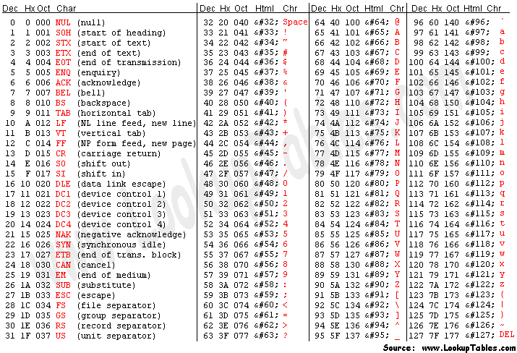

# Extended ASCII Codes

